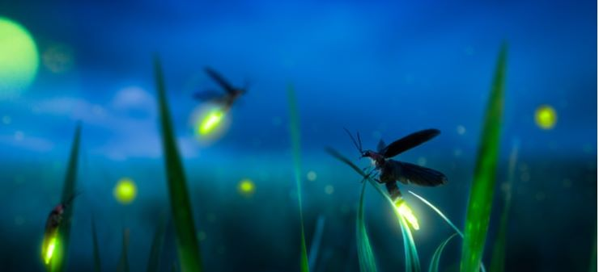
Hello Neighbor!
The recent virus has reminded us about the great outdoors. From our home at ADDRESS, we have watched so many more walkers, runners, bikers, skaters and dogs than we have watched for the almost XX years that we have lived at our house.
Recently, I have learned about the International Dark-Sky Association (IDA). Our days have a day and a night. During the night, we should be able to more see stars and planets. We should be able to see our magnificent Milky Way. Unfortunately, because of light pollution, we can see with the naked eye only 31 of the tens of thousands of stars that we should be able to see. Only decades ago, before the flood of outdoor lights, we could see thousands of stars. We could see meteor showers. Vincent van Gogh said while painting one of his many starry night masterpieces; “It often seems to me that the night is much more alive and richly colored than the day.”
Like the stars and planets, we also have fewer fireflies, also known as lightning bugs. Outdoor lighting affects not just the fireflies, but our night-time pollinators, like the moths. The moths are attracted to our bright white outdoor lights. Instead of pollinating our flowers, fruits and vegetables, they circle the lights and tire and die. Also, during Spring and Fall, many birds that migrate and travel to or through the Chicago region become distracted by the increasingly bright and unshielded LED lights. Birds migrate a night. So many get lost in the bright lights. Some strike buildings. Too many birds and insects die because of light pollution.
So, I’d like to challenge my neighbors to join me and to manage the intensity and duration of our outdoor lights/lighting. While I understand that many of us cannot afford to replace our outdoor fixtures with fixtures that shield the light from shining up and out from our homes and garages, we can install LED bulbs that are not more than 2700 Kelvin and not more than 800 lumens. These bulbs are inexpensive and are available at all local hardware stores. Also, and maybe more importantly, we can turn off our outdoor lights after 10pm or after whatever time makes us most comfortable. We can use motion sensors.
Although we may have to keep our distance and wear a mask, we can have a gathering on our block, turn off the lights and look up to the sky together. Maybe we can also enjoy a few more fireflies. If any of you are interested, please stop by to chat or email me at EMAIL. Also, please visit the IDA website; www.darksky.org or the IDA Facebook or Instagram pages. Let’s Go Dark!
Your neighbor,

NAME

