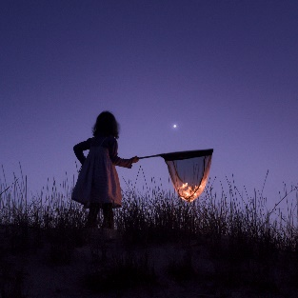
Hello Neighbor!
From when we sent our first letter about outdoor light pollution and fireflies, we have noticed that many of you have decided to keep your lights off at night or have decided to turn your lights off at 10ish. THANK YOU!
The fireflies have started to join us. With less outdoor lighting at night, the fireflies can better communicate and find a mate. As a result, we will have more and more fireflies lighting our yards naturally. These jewels of the night depend on us to improve their habitat.
The Xerces Society published an article titled; The Night Shift: Moths as Nocturnal Pollinators. When our day-active (diurnal) pollinators turn in for the evening, nocturnal pollinators, such as moths, take the night shift to pollinate our flowers, including many flowers that are not often visited by diurnal pollinators.
Unfortunately, like many of our nocturnal wildlife friends, moths are very much affected by artificial light at night. Artificial lights disorientate moths, and recent research has found this can impair with finding mates, evading predators and pollinating plants. A recent study found that nocturnal visits to plants was reduced by 63 percent in areas with artificial illumination compared to more dark areas!
For those of us who prefer to leave our lights on through the night, please consider installing “Soft White” LED bulbs and new fixtures that shield the light down onto the ground as compared to out and up. Soft White bulbs, which are 2700 Kelvin and 450 lumens (40 watts), have significantly less blue/white light and are very much less intrusive. Better yet, regardless of the bulb we choose, a fixture that guides our light down onto our stoops, aprons and drives will remove the artificial light from our lawns and, most importantly, our gardens and flowers. You can see examples at www.darksky.org.
Thank you and I hope you are enjoying our darker neighborhood!
Your neighbor,
NAME

